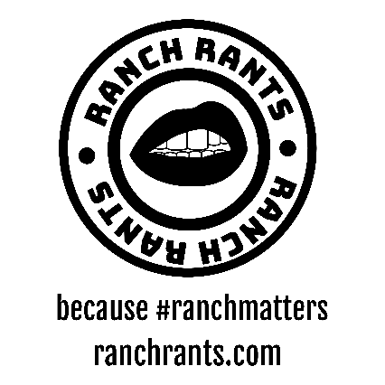

We get it, some people do not want to read a life story when trying to get the ingredients for a recipe. We understand that and wanted to provide those “straight to business” ranch feens a quick rating list. Please check back weekly for updates!
- 0/10 = I’d rather drink my own pee, or they don’t have ranch (both disgusting)
- 5/10 = Good in a pinch but really you are just “getting by”
- Anything 8/10 and higher is high quality ranch
- 10/10 = **Chefs Kiss** PERFECTION!!!

North Park/South Park | Hillcrest | Downtown | Chain Restaurants | Pizza Places | Fast Food
San Diego Chicken Pie Shop (10/10) | Gossip Grill (9/10) |  | Denny’s (10/10) | Mr. Moto (10/10) | Wings Stop (10/10)
Station Tavern (6.5/10) | Urban Mo’s (8.5/10) |  | Hooley’s (9/10) | Sisters Pizza (10/10) | McDonald’s (5/10)
 | Baja Betty’s (8/10) |  | Dirty Birds (9/10) | Pizza Hut (6.5/10) | Carl’s Jr. (4/10)
 | Hash House (0/10) |  | Outback Steakhouse (8.5/10) | Lefty’s (5/10) | Jack in the Box (3/10)
 | Bo Beau Kitchen (0/10) |  | Chili’s (8/10) | Filippi’s Pizza Grotto (3/10)
 |  |  | Phil’s BBQ (8/10) | Bronx Pizza (0/10)
 |  |  | California Pizza Kitchen (7.5/10)
 |  |  | Crab Hut (3/10)
 |  |  | Applebee’s (0/10)
 |  |  | TGI Fridays (0/10)
 |  |  | Farmer & The Seahorse (0/10)

